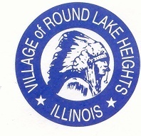

www.villageofroundlakeheights.org June 2021

Dear Residents:
Mark your calendars for our annual Village Wide Garage Sale June 24th – June 27th and summer Clean-up will follow Friday, July 2nd. The Villages new website will be live this month. All residents will be able to sign up for Village alerts or any new information that is uploaded. Thank you for your patience during this updating.
Please do not hesitate to contact me if you have any questions.
Sincerely,

-Terrance Lumpkins, Mayor

Code Enforcement

Village code 4-4-4 maintenance requirements-grass cutting. Grass and other vegetative growth shall not exceed eight inches (8”) in height; the owner or occupant shall cut or caused to be cut to a height of less than eight inches (8”).

Failure to comply could result in a fine or summons to court.

Sewer Credits
Sewer Credits are now available from
June 1st - October 15th.
Please call the Village by the 15th of the month to see if you qualify for a Sewer Credit.

Electronic Recycling
A drop off area for electronic recycling is located at the:
Grayslake Public Works Facility, Recycling Center, 585 Berry Ave, Grayslake, IL Monday thru Friday 7:00am-3:30pm
Saturday 8:00am-noon.
For any questions contact SWALCO 847-336-9340.

Senior Corner

“It isn’t the big pleasures that count the most; it’s making a big deal out of the little ones.”
~ Jean Webster

What travels all around the world but stays in one corner?
A: A postage stamp!
Please remember if the weather is too extreme to stay in your home call the Village Hall 847-546-1206 you may use the Village as a cooling station during hours if needed.

Fun Fact
No other month in the year begins on the same day of the week as June.
June has both the longest and the shortest days of the year, depending on where you’re standing! If you live in the northern hemisphere, then June 21st is the longest day of the year. If you live in the southern hemisphere, then the 21st is the shortest day of the year.

** SUMMER CLEAN-UP DAY **
FRIDAY, July 2nd

The Village of Round Lake Heights is having SUMMER CLEAN~UP day!
This is a day where Groot will pick up any garbage that you are looking to get rid of.
This does not include food, appliances, electronics or liquids of any type.
Please have all garbage out after 6:00pm on Thursday, June 25th. Groot will not come back if you miss this opportunity for summer clean-up day!

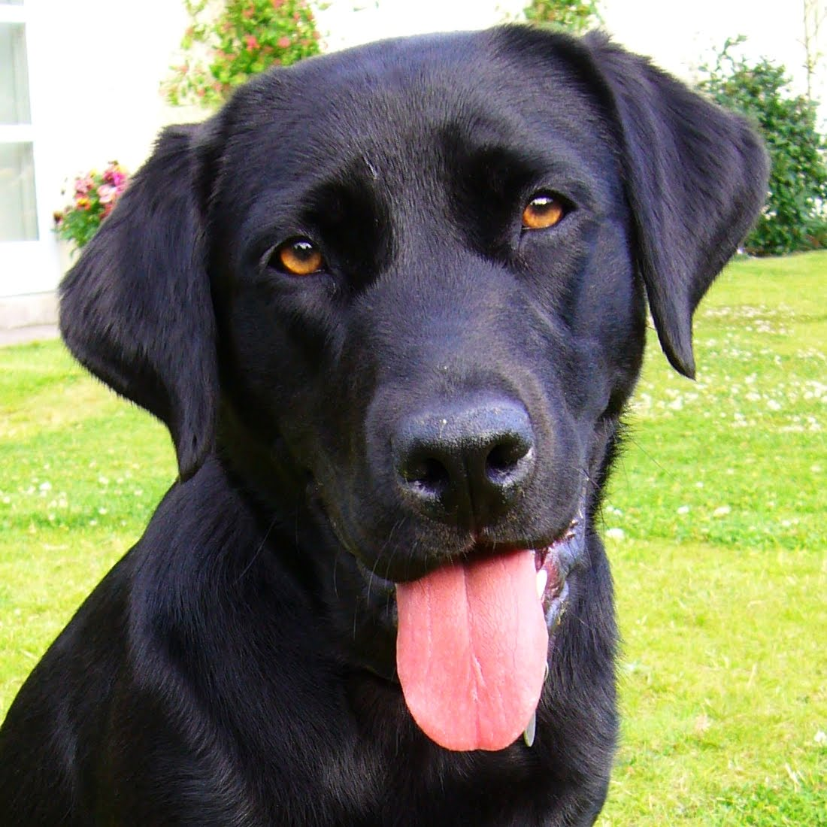REGISTRATION FOR PETS OF RLH
The Village of Round Lake Police Dept. has a program for pets of
Round Lake Heights.

Please call 847-546-1206 during business hours for information
or email gconover@rlhpd.org.

