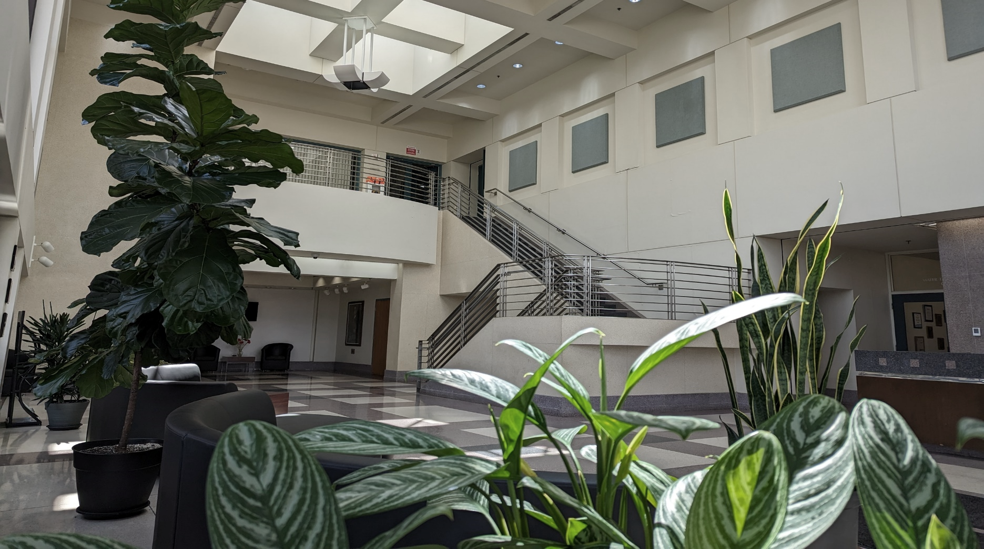

Water Quality Report
  - 2022
This is your annual water quality report for the period of January 1 through December 31, 2022. Each year the Village issues this report to provide you information about the quality of our drinking water, the source of our water, how it is treated, and the regulated compounds it contains. These reports are issued in compliance with the Safe Drinking Water Act. For more detailed information about our water's quality, including test results for unregulated compounds, contact Melissa Olenick at CLCJAWA at 847-295-7788 or email at molenick@clcjawa.com, contact George Johnson at 847-546-1206, visit our website at www.villageofroundlakeheights.org, or visit the CLCJAWA web page at www.clcjawa.com. Este informe contiene informaciόn muy importante sobre el agua que usted bebe. Tradúzcalo ό hable con alguien que lo entienda bien.  Some people may be more vulnerable to drinking water contaminants than the general population. Immune compromised persons such as persons with cancer undergoing chemotherapy, persons who have undergone organ transplants, people with HIV/AIDS or other immune system disorders, some elderly, and infants can be particularly at risk from infections. These people should seek advice from their health care providers about drinking water. The USEPA and Center for Disease Control (CDC) guidelines on appropriate means to lessen the risk of infection by Cryptosporidium and other microbial contaminants are available from the USEPA Safe Drinking Water Hotline at 1-800-426-4791. |  |  |  | A Look Ahead  Lake Michigan & PFAS ------ Pg. 2  Regulations and Lead ------- Pg. 3  Detected Contaminants ----- Pg. 4  Treatment Process ----------- Pg. 5  The Village of Round Lake Heights and CLCJAWA were in full compliance with all State and Federal Drinking Water Regulations in 2022
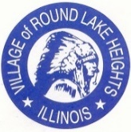
Village of Round Lake Heights - 619 W. Pontiac Ct. - Round Lake Heights, IL
www.villageofroundlakeheights.org - 847 - 546 - 1260
Striving for Excellence  Central Lake County Joint Action Water Agency (CLCJAWA) has received the Excellence in Water Treatment award for the last 18 years and was the third facility in the nation to achieve this distinction presented by the Partnership for Safe Water. This voluntary water quality program, sponsored in part by the United States Environmental Protection Agency, holds its awardees to higher standards than required by current Federal and State drinking water regulations.  CLCJAWA was 5th in the nation to be honored with the Partnership for Safe Water Distribution System Presidents Award. This is a significant achievement towards ensuring the delivery of safe, high-quality water to the community. |  |  | 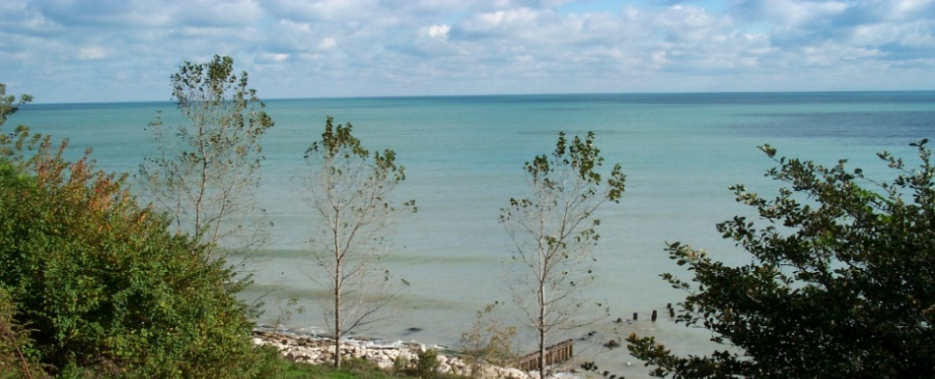  Going Beyond Compliance  Lake Michigan is the sole water source for CLCJAWA. More than 20% of the world’s fresh water is contained in the Great Lake and Lake Michigan is the only Great Lake that is entirely contained within the United States. It borders Illinois, Indiana, Michigan, and Wisconsin, and is the second largest Great Lake by volume with 1.3 quadrillion gallons. It is approximately 118 miles wide and 307 miles long. To lower the lake level by just one inch, you would need to drain 400 billion gallons.  CLCJAWA is required under state and federal law to monitor water quality. While we carefully do so, we go above and beyond by voluntarily monitoring for hundreds more compounds. Basic water chemistry is continuously monitored with automatic instrumentation or manually tested at our laboratory by our certified lab analysts. Emerging contaminants such as PFAs, pharmaceuticals and hormones have been monitored since 2008 and are tested independently by certified testing laboratories. We test both the raw water entering our system from Lake Michigan, as well as the finished water.
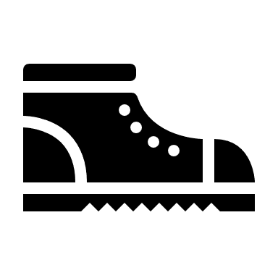  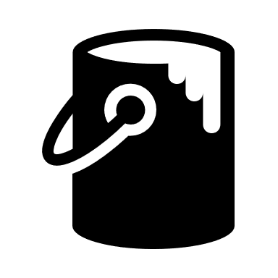  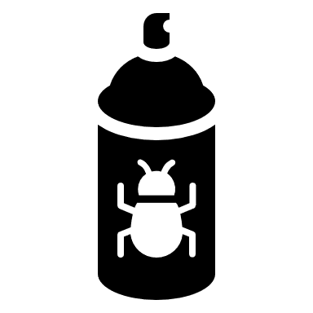  PFAS in Water |  | The Illinois EPA conducted a PFAS Statewide Investigation in 2021. Results from that sampling indicate that PFAS were not detected in CLCJAWA drinking water and were below the state health advisory level that was established by the Illinois EPA. CLCJAWA has been proactively testing for PFAs since 2008. In 2022, both PFOA and PFOS were present just above the detection limit of 2 parts per trillion. See the table below for the testing results. The US EPA has proposed regulation to establish legally enforceable, maximum contaminant levels for PFOA and PFOS.  CLCJAWA currently meets all US EPA proposed regulations for PFAS and will continue to comply with all EPA drinking water standards in order to provide the highest quality of water to our customers.  For more information, please visit the links: https://www.epa.gov/pfas/pfas-explained, https://epa.illinois.gov/topics/water-quality/pfas.html and https://www.clcjawa.com/water-quality/in-the-news.
Lake Michigan Susceptibility to Contaminants
Drinking water, including bottled water, may reasonably be expected to contain small amounts of some contaminants. The presence of contaminants does not necessarily indicate that water poses a health risk. More information about contaminants and potential health effects may be obtained by calling the US Environmental Protection Agency's (USEPA) Safe Drinking Water Hotline at 1-800-426-4791. Both tap and bottled water come from rivers, lakes, streams, ponds, reservoirs, springs, and wells. As water travels over the surface of land or through the ground, it dissolves naturally occurring materials and can pick up substances resulting from the presence of animal or human activity. Contaminants that may be present in untreated water include:
- Microbial contaminants such as viruses and bacteria can be naturally occurring or may come from sewage treatment plants, septic systems, and livestock operations.
- Inorganic contaminants such as salts and metals can be naturally occurring or result from urban storm water runoff, wastewater discharges, oil and gas production, mining, or farming.
- Pesticides and herbicides come from sources such as agricultural, urban and residential storm water runoff.
- Organic chemical contaminants including synthetic and volatile organic compounds are by-products of industrial processes and petroleum production but can also come from gas stations, urban storm water runoff and septic system.
- Radioactive contaminants can be naturally occurring or be the result of oil, gas and mining activities. Pesticides and herbicides come from sources such as agricultural and residential storm water runoff.
Elevated levels of lead can cause serious health problems, especially in pregnant women and young children. Some homes with old lead service lines, lead plumbing, or copper plumbing with lead solder, may have lead and copper in their water. To minimize these levels, the Illinois EPA requires that CLCJAWA add phosphate to our water at a concentration of 0.3 ppm orthophosphate. This commonly used food ingredient thinly coats the inside of your premise plumbing.
Lead in drinking water is primarily from materials and components associated with service lines and home plumbing. We cannot control the variety of materials used in plumbing components. For the best quality and to minimize the potential for lead and copper exposure, you may flush your tap until the water is cool or for 30 seconds to 2 minutes before using the water for drinking or cooking. To know with certainty whether you have lead or copper in your drinking water, have your water tested at a certified laboratory.
Water providers are now generating an inventory of all known lead service lines in use, and are issuing public notification to homeowners of local water main construction or repair work that might increase the risk of lead exposure. For more information on lead in drinking water, testing methods and steps you can take to minimize exposure, contact the Safe Drinking Water Hotline at 1-800-426-4791 or go to http://www.epa.gov/safewater/lead.
Drinking Water Regulatory Agencies
To ensure tap water safety, the U.S. Environmental Protection Agency (USEPA) prescribes limits on the level of certain contaminants in our drinking water. Water quality may be judged by comparing our water to USEPA benchmarks for water quality. One such benchmark is the Maximum Contaminant Level Goal (MCLG). The MCLG is the level of a contaminant in drinking water below which there is no known or expected risk to health. This goal allows for a margin of safety. Another benchmark is the Maximum Contaminant Level (MCL). An MCL is the highest level of a contaminant that is allowed in drinking water. An MCL is set as close to an MCLG as feasible using the best available treatment technology.
Our tap water quality is consistently monitored by the Village, by the Illinois Environmental Protection Agency (IEPA), in the CLCJAWA Water Quality Lab, and by other independent labs. This aggressive water quality assurance program is thorough: bacteriological tests are conducted six times more often than required, water clarity is monitored continuously, and our water is checked for over two hundred contaminants annually.
WATER CONTAMINANTS DETECTED IN 2022
Contaminant (unit of measure)  Typical Source of Contaminant | Highest Level Detected | MCLG |  | MCL |  | Range of Detection |  | Violation | Date of Sample
M I C R O B I A L C O N T A M I N A N T S
Total Coliform Bacteria (% Pos/Month)  Naturally present; human and animal fecal waste | 0 | 0 |  | 5%  per month |  | none |  | In Compliance | 12/2022  Monthly
E. Coli (% Pos/Month)  Naturally present; human and animal fecal waste | 0 | 0 |  | 0%  per month |  | none |  | In Compliance | Monthly
Turbidity (NTU/Lowest Monthly % < 0.3 NTU)  Lake Sediment; soil runoff | 100%  below 0.3 NTU | none |  | 0.3 NTU |  | 100% |  | In Compliance | Monthly
Turbidity (NTU/Highest Single Measurement)  Lake Sediment; soil runoff | 0.052 | none |  | 1 NTU |  | 0.01 – 0.052 |  | In Compliance | Monthly
I N O R G A N I C / O R G A N I C C O N T A M I N A N T S
Nitrate as nitrogen (ppm)  Runoff from fertilizer; leaching from septic; natural erosion | 0.33 | 10 |  | 10 |  | Single Sample |  | In Compliance | 5/11/22
Barium (ppm)  Discharge of drilling wastes, metal refineries; natural erosion | 0.021 | 2 |  | 2 |  | Single Sample |  | In Compliance | 9/28/22
Combined Radium 226/228 (pCi/L)  Decay of natural and man-made deposits | 0.94 | 0 |  | 5 |  | Single Sample |  | In Compliance | 5/5/21
Copper (ppm)  Corrosion of household plumbing systems; natural erosion | 0.11  90th Percentile |  | 1.3 | AL = 1.3 |  | 0  Sites over AL |  | In Compliance | 8/30/2021
Lead (ppb)  Corrosion of household plumbing systems; natural erosion | 1.1  90th Percentile |  | 0 | AL = 15 |  | 0  Sites over AL |  | In Compliance | 8/30/2021
D I S I N F E C T A N T / D I S I N F E C T I O N B Y – P R O D U C T S
HAA5 Haloacetic Acids (ppb)  By-product of drinking water disinfection | 4 | None |  | 60 | Single Sample |  |  | In Compliance | 8/9/2022  Annual
TTHMs Total Trihalomethanes (ppb)  By-product of drinking water disinfection | 33 | None |  | 80 | Single Sample |  |  | In Compliance | 8/9/2022  Annual
Bromate (ppb)  By-product of drinking water disinfection | 1 | 0 |  | 10 |  | 0 – 4.7 |  | In Compliance | 9/12/22  Quarterly
Chlorine (ppm)  Drinking water disinfectant | 0.6 | 4 |  | 4 | 0.5 - 0.6 |  |  | In Compliance | Monthly
TOC (Total Organic Carbon) | The % of TOC removal was measured each month & the system met all removal requirements set by IEPA
S T A T E R E G U L A T E D C O N T A M I N A N T S
Fluoride (ppm)  Water additive that promotes strong teeth; natural erosion | 0.6 | 4 |  | 4 |  | 0.54 – 0.74 |  | In Compliance | 9/28/22  Monthly
Sodium (ppm)  Erosion of naturally occurring deposits; water softener | 10 | none |  | none |  | Single Sample |  | In Compliance | 9/28/22
P R O P O S E D P F A S C O N T A M I N A N T S
PFOA Perfluorooctanoic acid (ppt)  Produced during production of chemicals that are heat and chemical resistant. | 2.4 | 0 |  | 4 |  | 2.1 – 2.9 |  | Proposed New Regulation | Quarterly
PFOS Perfluorooctanesulfonic acid (ppt)  Ingredient in firefighting foam and was an ingredient in Scotch Guard fabric protector. | 2.4 | 0 |  | 4 |  | 2.0 – 3.0 |  | Proposed New Regulation | Quarterly
The table above lists all of the regulated compounds detected in our water. Bolded compounds were sampled by the Village; all other compounds were sampled by CLCJAWA. The values shown in the level detected column are those used by the EPA to determine compliance with drinking water standards. Because each compound is regulated differently, this value may be a running average, a 90th percentile or a maximum single value. The sample data column indicates the date when the sample was collected. When more than one sample is collected, this column shows the date of the maximum value.
Definition of Terms:  Action Level (AL): level that triggers special treatment or other required action by water plants  Maximum Contaminant Level (MCL): the highest level of contaminant that is allowed in drinking water  Maximum Contaminant Level Goal (MCLG): level of a contaminant below which there is no known or expected health risk  Treatment Technique (TT): required process used to reduce contaminants in drinking water |  |  |  |  |  |  | Units of Measure:  ppm: parts per million or milligrams per liter  ppb: parts per billion or micrograms per liter  ppt: parts per trillion or nanograms per liter  pCi/L: picocuries per liter to measure radioactivity  NTU: nephelometric turbidity unit that measures clarity in drinking water
Our Treatment Process
Our water is pumped from Lake Michigan and treated at CLCJAWA’s Paul M. Neal Water Treatment Facility in the Village of Lake Bluff.
The enhanced water purification process used by CLCJAWA is unique.

Villages purchase water from the Central Lake County Joint Action Water Agency. CLCJAWA is an inter-governmental cooperative, directed by the communities it serves: Grayslake, Gurnee, Lake Bluff, Lake Villa, Libertyville, Lindenhurst, Mundelein, Round Lake, Round Lake Beach, Round Lake Heights, Round Lake Park, Volo, Wauconda and Lake County representing the unincorporated areas of Knollwood and Rondout, Vernon Hills, Wildwood, Grandwood Park and Fox Lake Hills. CLCJAWA utilizes over 50 miles of pre-stressed concrete, ductile iron and PVC water main to deliver water to your community. Your public works department, in turn, maintains its own water distribution system that delivers the water to homes, schools and businesses in the community.

The Village is in the process of completing a multi-year water system improvement plan. These improvements are a continuation of the 15-year comprehensive water main replacement program that was initiated in 1997. These improvements further assure the continued, uninterrupted conveyance of quality drinking water to your tap. The Village also maintains an emergency back-up well. This well is exercised and tested regularly for quality assurance. Please contact us if you would like to review the test results.
The Village Board has a monthly meeting schedule, and the public is always welcome to attend any of these meetings. Your Mayor is also a member of the Board of Directors of CLCJAWA, which meets regularly. Please visit the website at www.clcjawa.com for the current meeting schedule. CLCJAWA provides tours of the water treatment facility, and staff members are also available for public speaking or for school visits. Please contact the Village or CLCJAWA for more information. | Assessing Our Source  The Illinois EPA, using the Great Lakes Protocol, completed a source water assessment in April 2003. Lake Michigan is a surface water source and like all surface waters, is susceptible to potential contaminants. The very nature of surface water allows contaminants to migrate to the intake with no protection, only dilution. CLCJAWA’s intake is ranked as moderately sensitive to potential contaminants. There are no potential contamination sources within the intake’s critical assessment zone. However, the combination of land use, storm sewer outfalls, and the proximity of North Shore Water Reclamation District (NSWRD) pumping stations in the immediate area add to the susceptibility of CLCJAWA’s intake. NSWRD discharges their treated waste water to the Des Plaines River and not into Lake Michigan. Access the following website at http://www.epa.state.il.us/cgi-bin/wp/swap-fact-sheets.pl to view a summary of the source water assessment. We are all participants in the water cycle. Our individual activities impact the rivers and lakes in our watershed and those into which our waste water plants discharge. Please properly use, store, and dispose of all medications and household chemicals. Visit the Solid Waste Agency of Lake County website for disposal options and information at www.swalco.org.

