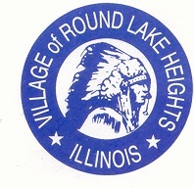

www.villageofroundlakeheights.org April 2024
Dear Residents:
Happy Spring, wishing you and your families a Happy Easter Holiday! Mark your calendars for the Village wide garage sale. The dates are Thursday, June 20th thru Sunday, June 23rd more information will follow.The following Friday, June 28th is summer clean up day.
We are getting excited for our Festival this year! Save the date for August 17th. We have SERENDIPITY back this year and Karla Perez as SELENA the SHOW as our headliner! We also have food trucks booked as well, La Pequena Mariposa, STIX & NOODLES &The Grilled Cheese Food Truck along with Nothing Bundt Cakes. We are looking for crafters so please put the word out to all your friends and family that may have interest.
For any resident continuing their education the Dollars for Scholars link is on the website under upcoming events. The Scholarships will close on May 13, 2024. Please fill out and complete your application correctly to secure your scholarship.
Please do not hesitate to contact me if you have any questions at 847-546-1206.
Sincerely,
-Terrance Lumpkins, Mayor

GROOT YARD WASTE PICK UP

Yard Waste Pickup will begin on Friday, April 5, 2024. All yard waste must be bagged in a brown paper lawn bag or 32 gallon can. Branches are to be tied in 4ft bundles.
Pick-up is on Friday mornings and such containers shall be placed on the parkway adjoining such premises within ten (10) hours before garbage pickup and shall be removed there from within ten (10) hours after the pickup service is rendered.

Please do not rake leaves to the side of the road as leaf pick up is in the fall. All leaves that you need picked up earlier are to be bagged and tagged with yard waste stickers.

NO STICKERS ARE REQUIRED FOR YARDWASTE

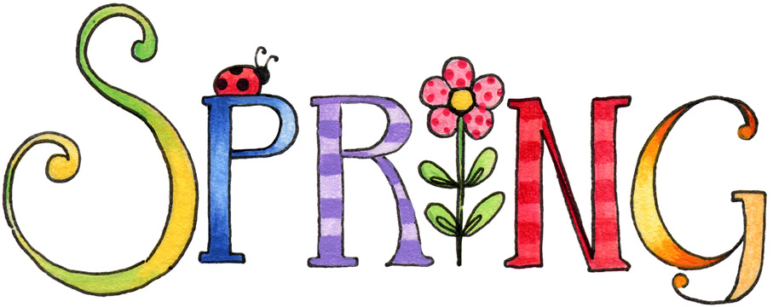

Holiday Lights

Holiday lights are designed for temporary use and shall be permitted for a period not to exceed 90 days per NEC Code 527.3B to prevent hazards and safety issues.

PLEASE PICK UP AFTER YOUR DOGS

Any person owning, possessing, harboring or having the care, charge, control or custody of any dog or domestic animal shall immediately remove and there after dispose of any fecal matter deposited by said dog on public or private property without the consent of the owner or person in lawful possession of said property.

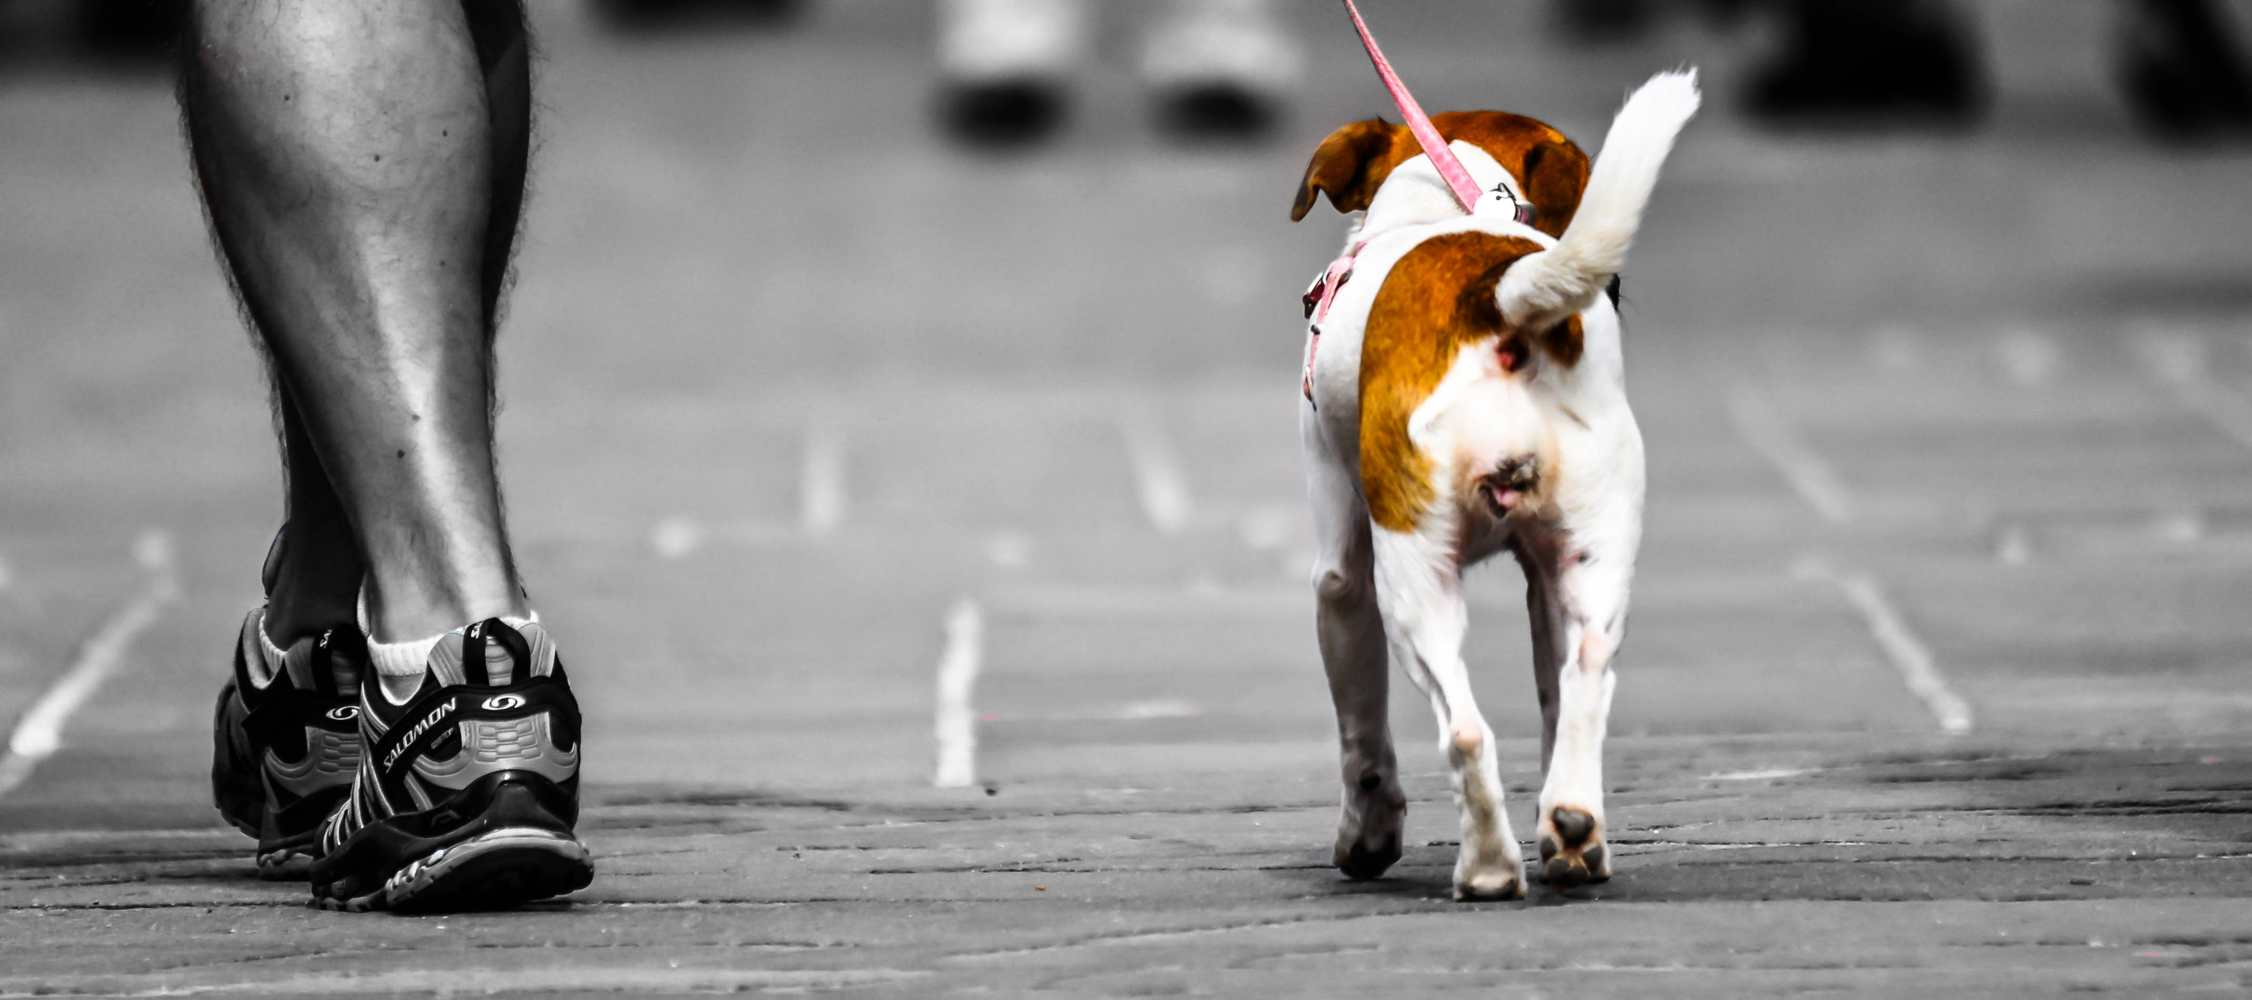

REGISTRATION FOR PETS OF RLH
The Village of Round Lake Police Dept. has a program for pets of
Round Lake Heights. Please visit the Village website for the form.
To locate search under departments then police department, you will then see pets of RLH.

