

[www.villageofroundlakeheights.org](http://www.villageofroundlakeheights.org) February 2024

Dear Residents:

I hope everyone is off to a great new year! Just a reminder when the weather is very cold outside, let the water drip from the faucet served by exposed pipes. Running water through the pipe, even a trickle helps prevent the pipes from freezing. Please keep your sidewalks and other walkways clean and salted to avoid injuries to all. Please remember that there will be no parking on Village Streets permitted when it is freezing rain or snowing, the plow needs to be able to plow the Village streets.

If have any questions don’t hesitate to contact me.

-Terrance Lumpkins, Mayor

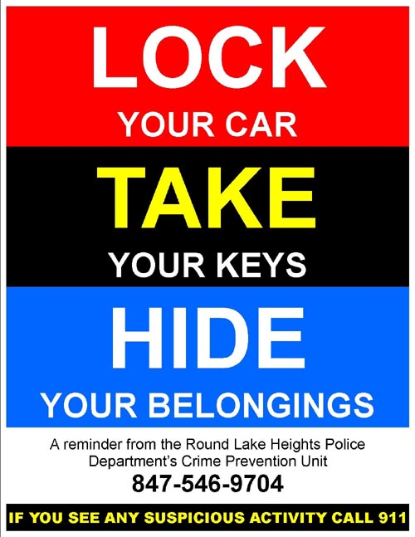

**Chief Schmidtke wants to advise all residents when starting your vehicle in your driveway to not leave it unattended this is**

**due to all the vehicle thefts in the area.**

Mailboxes



Please make sure your mailbox is attached securely to the post so the snow mounds or snow from the plow do not dislodge it. The Village will only repair or replace mailboxes/posts that have visual damage from our plow trucks. According to USPS regulations the face of the mailbox must be between six to nine inches back from the edge of the pavement or curb. The height from the ground to the bottom of the mailbox must be between 41-43 inches. The deadline for reporting a damaged or broken mailbox is May 1st.

**PLEASE PICK UP AFTER YOUR DOGS**

**Any person owning, possessing, harboring or having the care, charge, control or custody of any dog or domestic animal shall immediately remove and thereafter dispose of any fecal matter deposited by said dog on public or private property without the consent of the owner or person in lawful possession of said property.**

MC900024435[1]

**Village Hall**

**Holiday Schedule**

The Village will be closed on Monday, February 19th.

for observance of Presidents Day.

