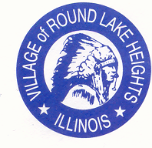
www.villageofroundlakeheights.org March 2024

Dear Residents:
The Village has been busy planning a family event at Arrowhead Park on August 17th! We have the band Serendipity and Selena the Show tribute band along with food trucks! Save the date. Please join the Village for our annual Easter Egg Hunt, see the attached flyer.
Dollars for Scholars information will be available shortly. We are setting up an online application for any of our residents who are continiuing education. When you see the Village post the signs for Dollars for Scholars is when you be will be able to go online.
If you have any questions please do not hesitate to contact me.

Sincerely,
-Terrance Lumpkins, Mayor

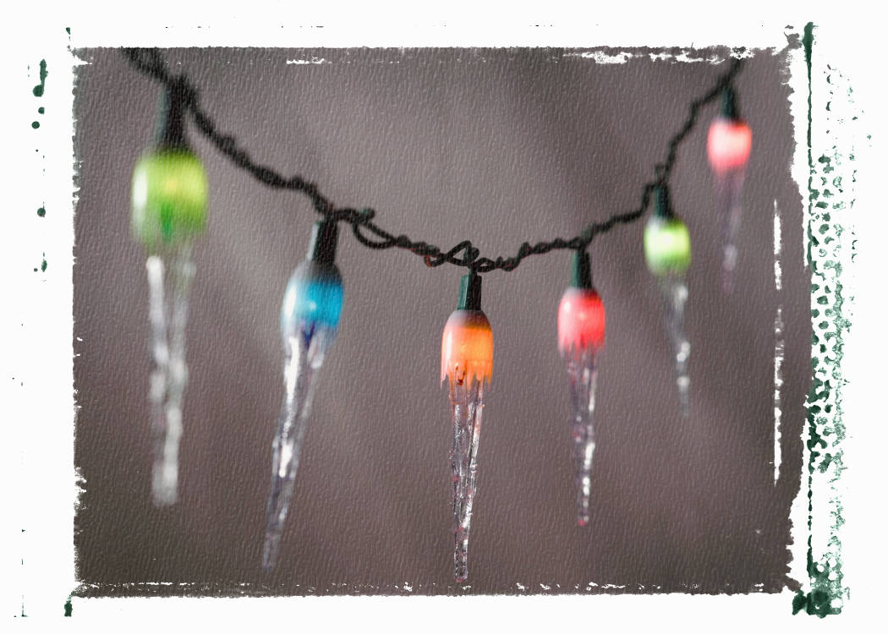
Per National Property Maintenance Code 7-6-1
Christmas lights must be removed by
March 31, 2024

Daylight Saving
Time Begins
Sunday, March 10, 2024
Set your clocks ahead one hour.

DONATIONS NEEDED

Please help support the Ronald McDonald House
by giving us your pop tabs!

Help children and families in need!
Drop off at the Village Hall.

