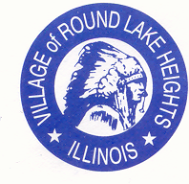

www.villageofroundlakeheights.org September 2023

Dear Residents:

I hope you and your loved ones had a great summer. School is back in session, use caution when driving through the Village. Thank you to all the residents who participated in the annual Village Festival and to the residents who came and supported. The Veterans Memorial plaques have been put up, if you had one made, visit the Veterans Memorial Park. We had a great turn out on the plaques, and they are still free of charge for any resident. Inquire at the Village Hall. See the Catholic Charities flyer they are always kind and always ready to help.
If you have any questions please do not hesitate to contact me at (847) 546-1206.

-Terrance Lumpkins,
Mayor

The Village Hall will be closed,
Monday, September 4th
In observance of Labor Day.

Swalco Electronic
Recycling drop off:

Grant Township
26535 Molidor
Ingleside, IL 60041
Monday-Friday
9:00am – 3:00pm
Visit
Swalco.org
for all recycling information.

Code Enforcement

Village code 4-4-4 maintenance requirements-grass cutting. Grass and other vegetative growth shall not exceed eight inches (8”) in height;
the owner or occupant shall cut or caused to be cut to a height of less than eight inches (8”).

